 | CAN THO UNIVERSITY SOFTWARE CENTER | 
 | MEKONG DELTA - APTECH
SEMESTER PROJECT – II
EMPLOYEE TRANSFER MANAGEMENT

Instructor: | Class: CP1896G05
Ms. Lê Thị Minh Loan | Team: 5
 | Students:
1. A18098 - Trần Ngọc Nguyên
2. A18108 - Hứa Huy Hoàng
3. A18110 - Nguyễn Thanh Hưng
4. A18054 - Phan Quang Lâm
Can Tho, 7/2019
Currently, ABC technologies Ltd has difficulty in managing employee transfer records. Although, employee transfer records are kept on computers, there is no fixed format for the records. The details are needed for creating employee transfer profiles are not in the same place. Senior managers want to know the details of the conversion, they have to get the information from the relevant departments. This becomes time consuming. Therefore, the manager decided to have a system to manage records for the transfer of employees. Building this system we need to develop an application for maintaining information relevant to the company's conversion employees and creating relevant conversion records. This application will be convenient for managers to search the conversion records, create conversions and modify the allowances provided to employees based on the position and type of conversion that employees receive, create monthly reports. The employee will be able to create a letter requesting conversion and view personal information. This system will be built on the Client-Server model and will be installed on all computers. The server will have hosting accounts for employees and managers with different access rights. Since then employees will restrict access to ensure confidentiality and safety of employee transformation record information.

Client/Project Undertaken: Employee Transfer Management.
- List of inputs to the system
- Employee information (Employee ID, Full Name, User name, Pass word, Gender, Date of birth, Date start work, Address, Phone).
- Admin information (Admin ID, Admin Name, User name, Pass word, Date of birth, Gender, Role, Address, Phone).
- Position information (Possition ID, Posssition Name, Position coefficient).
- Project information (Project ID, Project Name, Start day, End date, Project coefficient).
- Project type information (Project type ID, Project type name).
- List of ouputs expected from the system
- View employee personal information.
- View administrator information.
- List of records of transferred employees.
- List of allowances for employees.
- List of manager reports.
- Overview of processes involved in the system
When the application is opened, the login port is displayed and requires the user to confirm access. The system only contains logon information of employees and system administrators and conversion approvals (Director, Deputy Director):
- Administrator
- View employee information.
- Searching the transfer records.
- Updating the transfer records.
- Making new transfers.
- Generate the allowances.
- Create a report.
- Employee
- View personal information.
- Submit conversion request.
- Director, Deputy Director:
- Approval for the requested transfer.
- Create a delivery notice for staff.
- View project information, employee information, project type information, position information, transfer information.

- Hardware and software required for implementing the project
- Hardware Requirements:
- Server:
    - CPU: Intel Core i5.
    - RAM: 8GB or higher.
- Client:
    - CPU: Intel Core i3 or higher.
    - RAM: 4GB or higher
- Software Requirements:
- Server:
    - Windows 8/ 10.
    - SQL Server.
    - JDBC, JDBC Driver
- Client:
    - Windows 8/ 10.

S.No | Customer’s Acceptance Criteria
1.  1.1  1.2 | Login must be delegated.  Employees.  System Administrator.
2.  2.1.  2.2.  2.3. | Senior management of employee transfer records management.  Searching the transfer records.  Updating the transfer records.  Making new transfers.
3. | Create a registration form for employees who require a transfer.
4. | Create approval for employee transformation request.
5. | Create allowances for employees.
6. | Create a message to notify staff when the system has approved.
7. | Create report templates for managers.
8. | Logout.

Project Plan
- Project Details
- Name of the Client: Employee Transfer Management.
- Date of Project Plan: 10 - Sep - 2019
- Project Vision/Objectives:
(Define the project vision/objectives as started by the client)
- Provide ABC Technologies Ltd an application to maintain information regarding its employee transfers and create documents related to the conversion.
- Solve and fix problems that the company encounters.
- Help employees easily sign up to transfer their projects within the company.
- Help senior managers know the details of employee transfer accurately and quickly.
- Staff transfer records will be synchronized format.
- Increase efficiency and save management time for senior management
- Scope:
(Mention the Scope of the project giving the locations that: will be covered, processes, range of the services, and so on.)
Based on customer requirements, we will offer the positions to develop:
- The system will be maintained and updated regularly to ensure the system works best.
- The system will have the following functions:
- The system administrator will have the function: login, logout, view employee information, search transfer records, view employee transfer records, update records, make new transfers, create allowances for employees, create reports.
- Staff will have functions: login, logout, view their own information, request to transfer, view project information, update records, view project type information, view position information.
- Director, Deputy Director will have the functions: login, logout, approve employee requests, create notification letters for employees, view the type of records.
- Service scope of employee transfer system is based on client-server model.

- Our understanding of the client organization:
(Give the range of services, functions, overview of the process, and so on.)
- Build the functions required by the system.
- The system contains 3 login information: staff , administrator and Director(Deputy Director ).
- Employees can send requests to senior managers to convert, can view personal information.
- Senior management can view the information of conversion staff, approve, create allowances, create mail, create reports.
- Project Organization with Responsibilities and Authorities:
(Given the name of project team members theirs roles and responsibilities)
Fullname | Role | Responsibilities
Tran Ngoc Nguyen | Leader, Developer, Tester | Project planning, personnel planning for the project, code, document, testing.
Hua Huy Hoang | Developer, Tester | Code, document.
Nguyen Thanh Hung | Developer, Tester | Code, document.
Phan Quang Lam | Developer, Tester | Code, document.

- Project Initiation/Requirement Documents
- Based on ABC Technologies Ltd's request to transfer employees.
- Staff transfer procedure: at Cusc's training room.
- Build Client-Server application with Socket in Java: at the link (https://gpcoder.com/3679-xay-dung-ung-dung-client-server-voi-socket-trong-java/).
- Deliverables
- Source code
- Document: CRS, Design Document, Installation Manual, User Manual, Maintenance Manual, and Code documents.
- File .JAR.
- Project Dependencies
Any event or task outside the scope of the project, which will affect the success of the project
- Depend on time.
- Depend on Internet.
- Major Project Milestones

Important milestones of the project | Date
Customers send requests. | September 10, 2019
Determine customer requirements. | September 11, 2019
Analysis. | September 12, 2019
Design. | September 19, 2019
Code. | September 25, 2019
Test. | October 21, 2019
Deployment. | October 24, 2019
Maintenance. | 6 months maintenance once.

- Quality Plan
- Review Activities
- Three days review work once.
- Testing Activities
- All team members check together and solve it together.
- Backup and recovery strategies
- Save to USB.
- Upload Google Drive, Fshare, OneDrive.
Document Design
Property | Value
Document theme and color scheme | Violet, white
Form-Background color | White
Title-Font Size | 18
Title-Font Color | Black or White
Title-Font Style | Times New Roman
Title-Alignment | Center
Background color of Controls on the form | Violet
Foreground color of Controls on the form | White
Control Caption-  Font size | 14
Control Caption-  Font Style | Times New Roman
Control caption and controls-Alignment | Center
Command button-Alignment | Center

- List of forms to be created
Document Name | Description | Controls on the Document
Log in | This is log in form containing username, password and roles.  You have to enter the right username, password and select right role to access. | 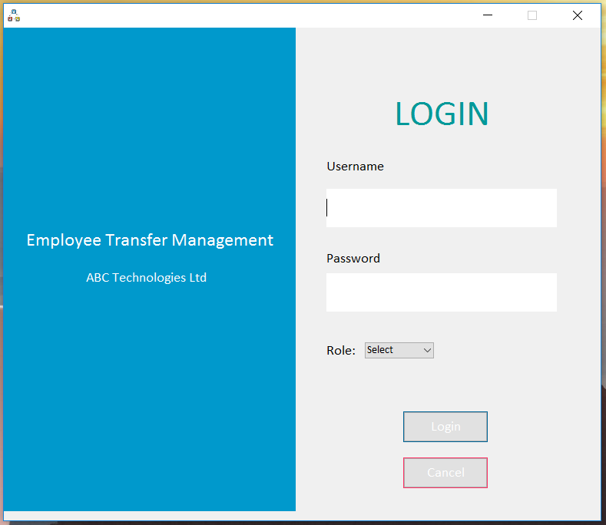
Manage project | Project management: administrators can add projects, edit project information, delete projects, and search projects. | 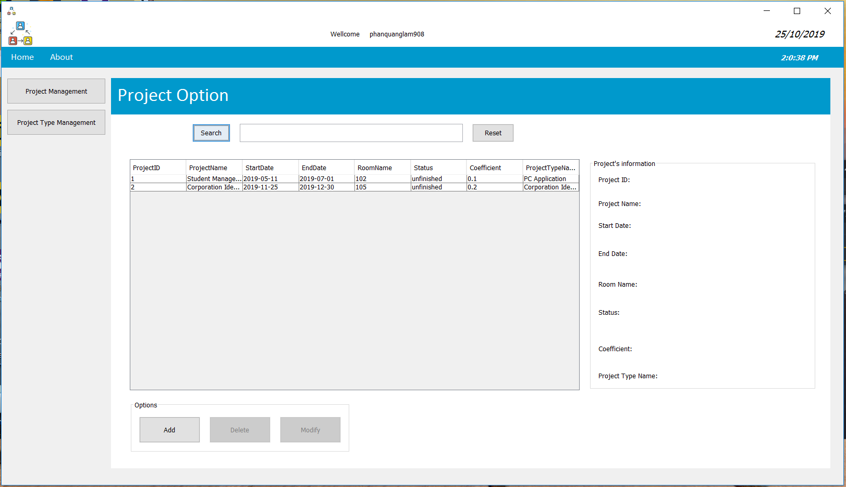
Manage project type | Project type management: administrators can add project type, edit project type information, delete project type, and search project type. | 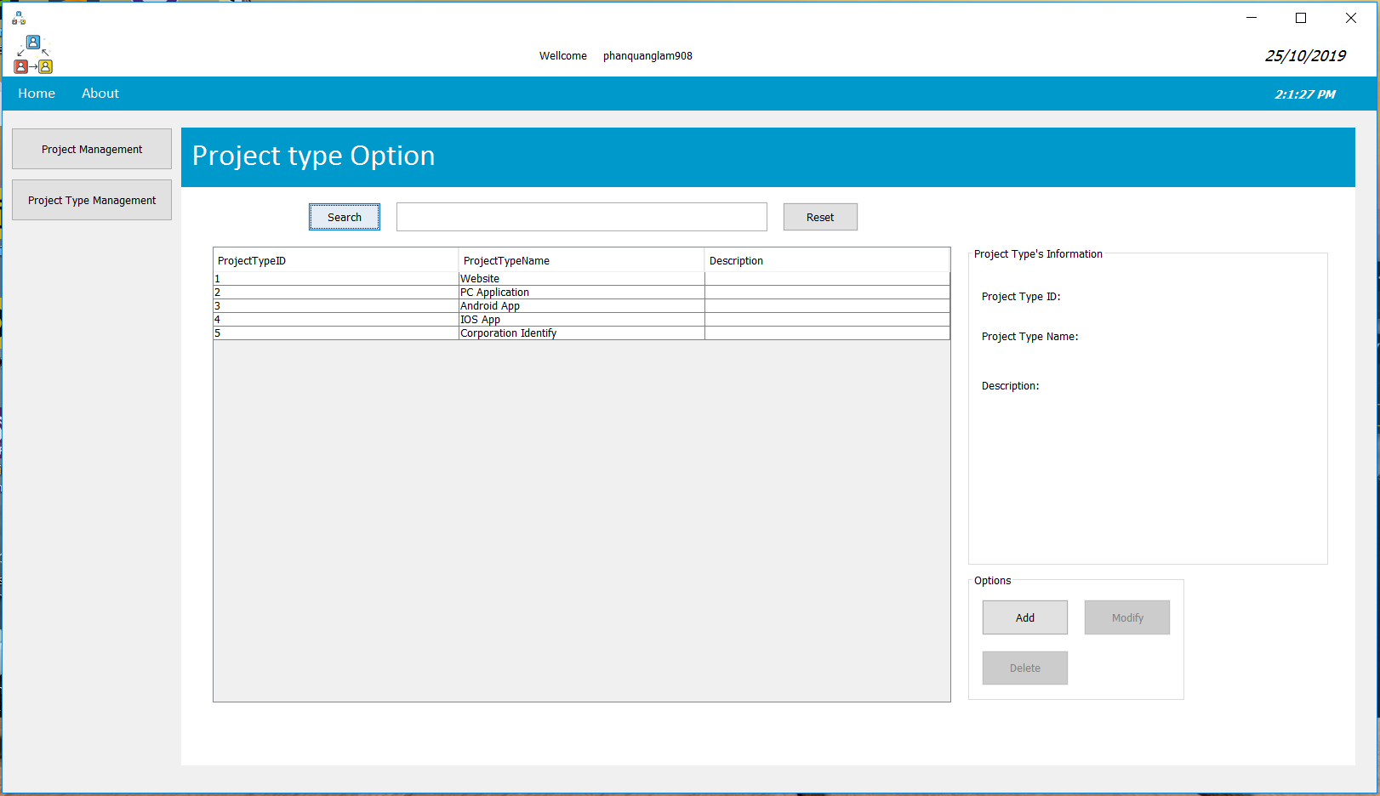

ER:
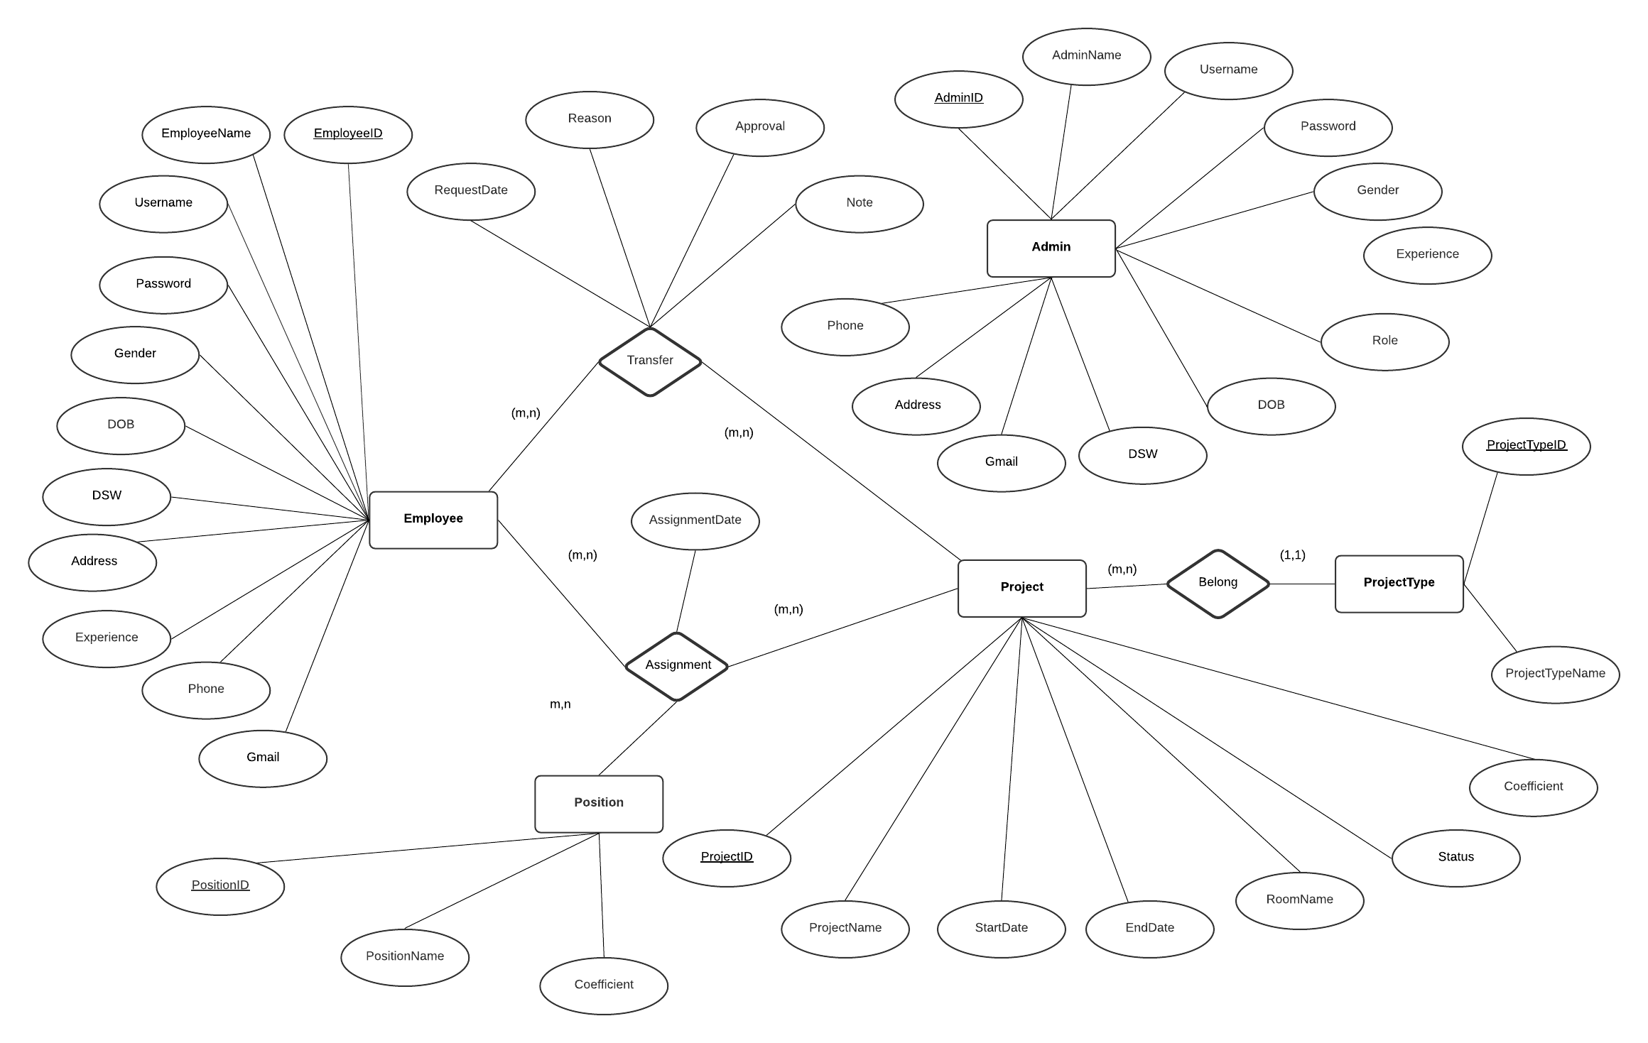

Name of the table | Table Description | Number of Fields | Primary Key | Related Tables | Foreign Key
Admin | Administrator data | - AdminID  - AdminName  - Gender  - DOB  - Role  - Experience  - DSW  - UserName  - Password  - Phone  - Gmail  - Address | AdminID
Project | Data of the project | - ProjectID  - ProjectName  - Start Date  - EndDate  - RoomName  - Status  - Coefficient  - ProjectTypeID | ProjectID | 1.ProjectType | ProjectTypeID
ProjectType | Data of project type | - ProjectTypeID  - ProjectTypeName  - Description | ProjectTypeID
Position | Data of position | - PositionID  - PositionName  - Coefficient | PositionID
Employee | Employee data | - EmployeeID  - EmployeeName  - Gender  - DOB  - Experience  - DSW  - UserName  - Password  - Phone  - Gmail  - Address | EmployeeID
Transfer | The data of theemployee who requested the transfer | - EmployeeID  - ProjectID  - Reason  - RequestDate  - Approval  - Note | EmployeeID  ProjectID | - Employee  - Project | EmployeeID  ProjectID
Assignment |  | - EmployeeID  - ProjectID  - PositionID  - AssignmentDate | EmployeeID  ProjectID  PositionID | - Employee  - Project  - Position | EmployeeID  ProjectID  PositionID

- Process Name
DFD level 0
- Process Description and Details

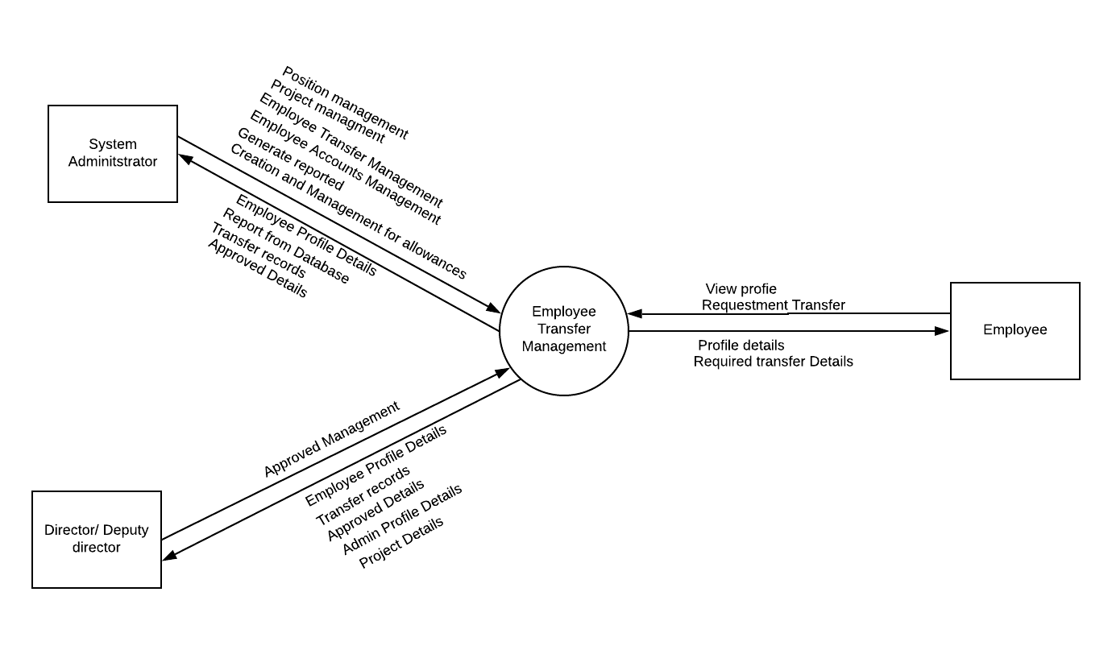
- Process Name
DFD level 1
- Process Description and Details

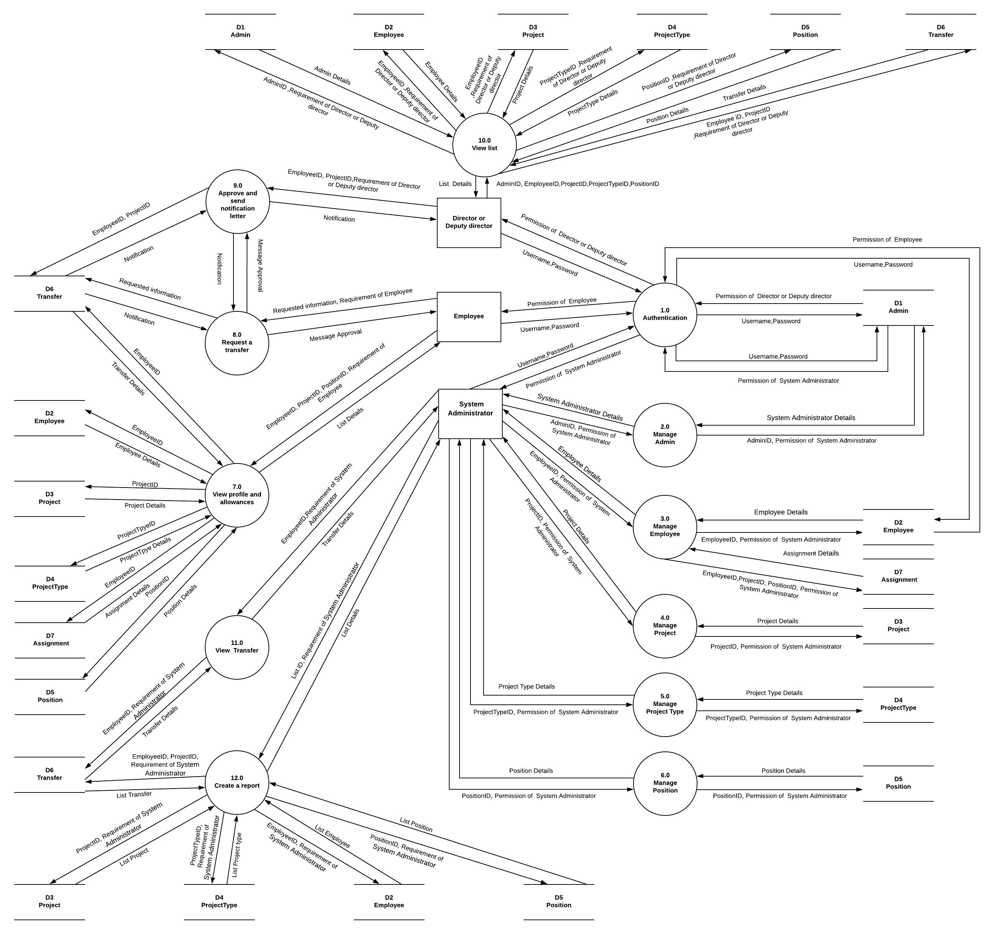

- Process Name
Admin account management.
- Process Description and Details

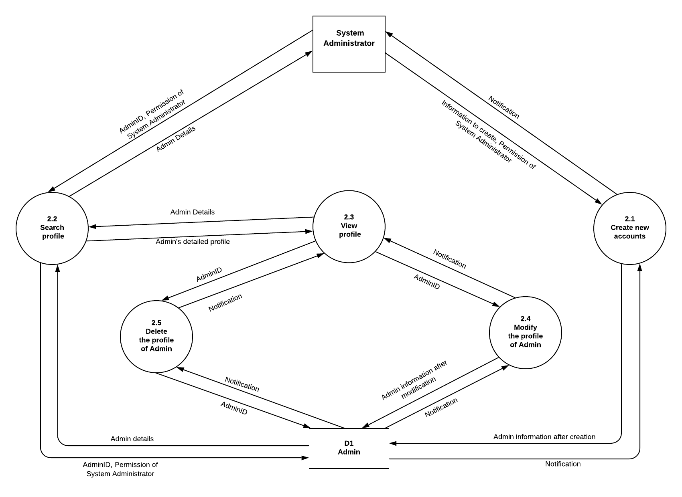

- Process Name
Employee management.
- Process Description and Details.

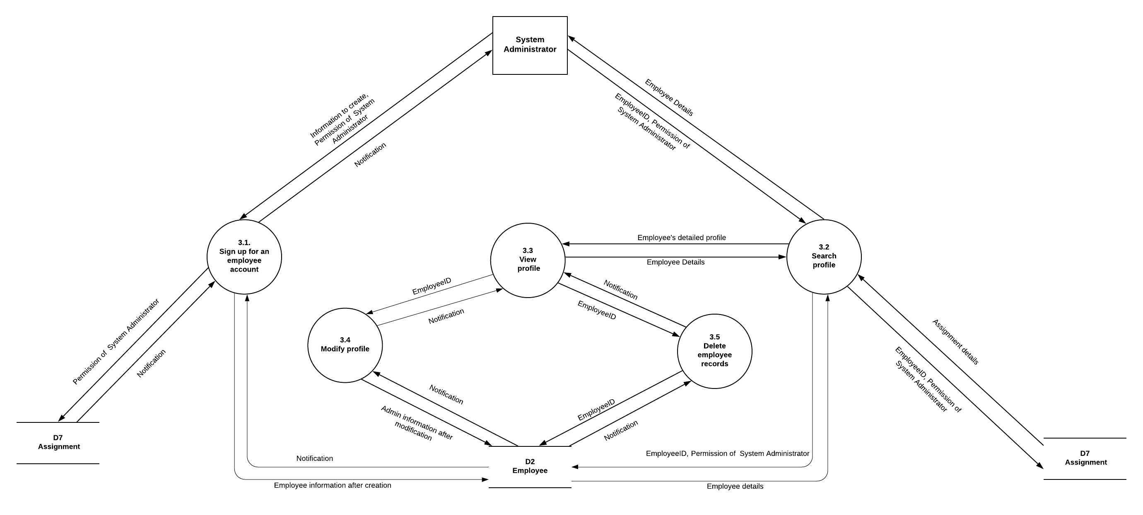

- Process Name
Manage project.
- Process Description and Details.

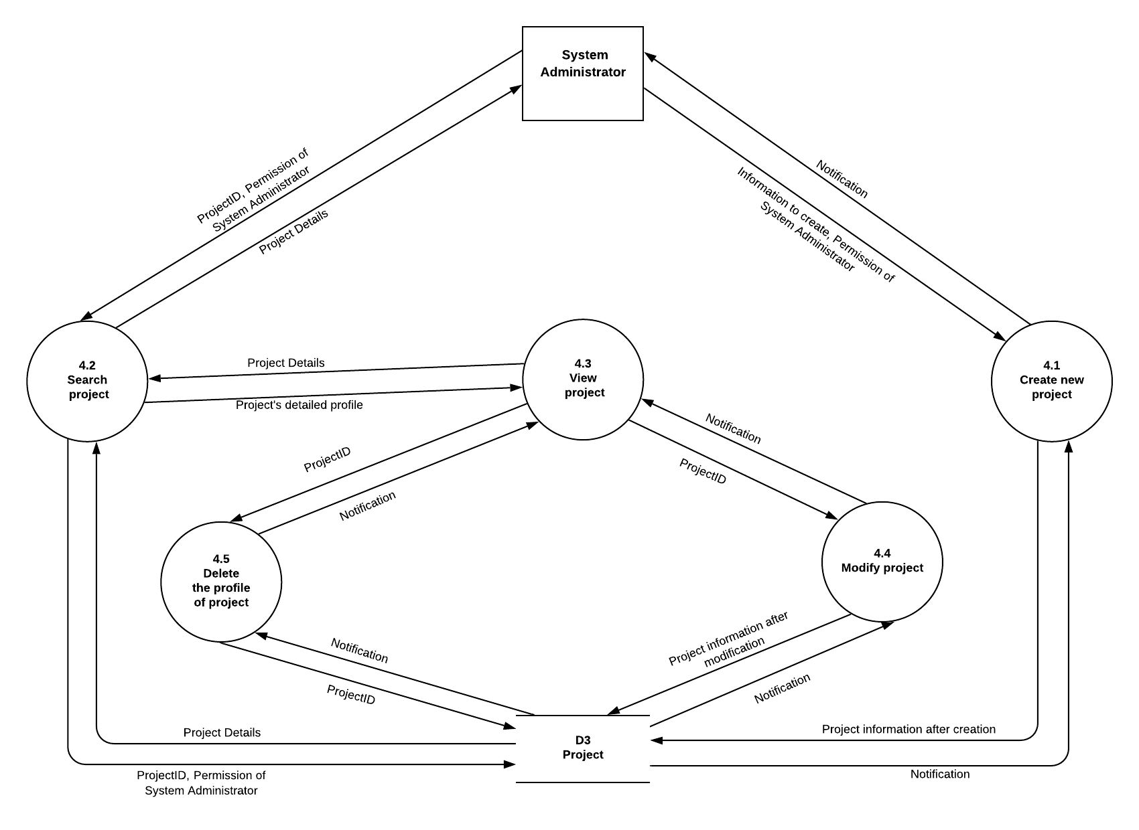
- Process Name
Manage project type.
- Process Description and Details.

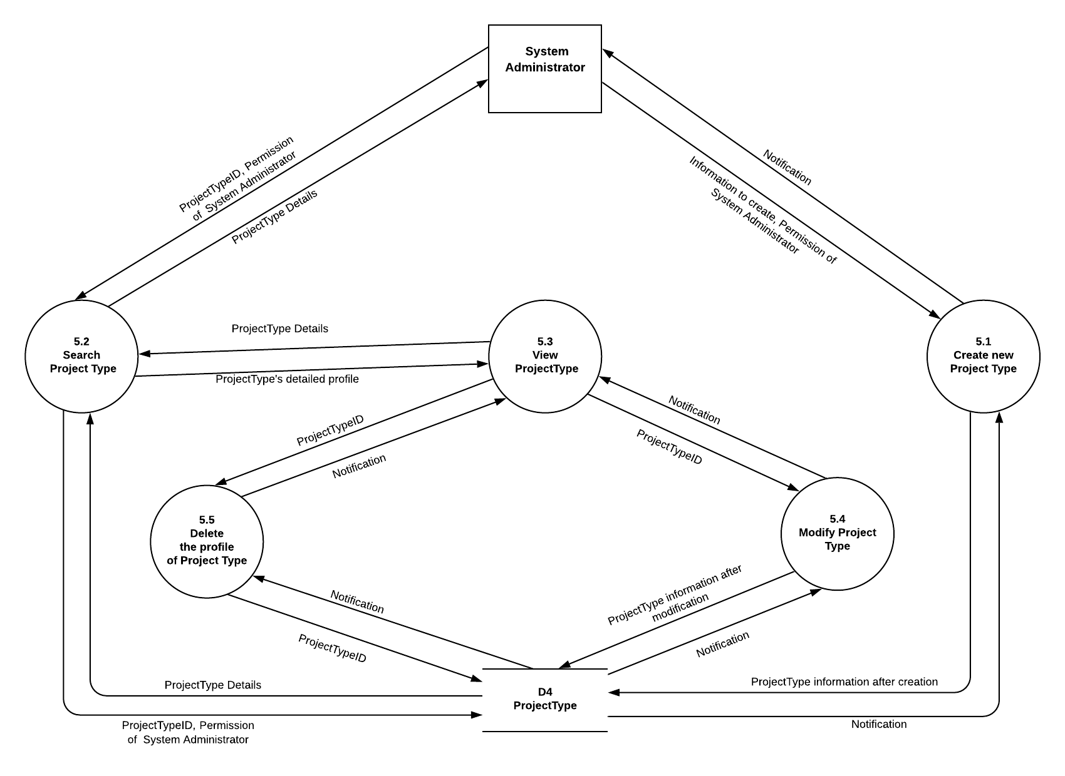

- Process Name
Manage position.
- Process Description and Details.

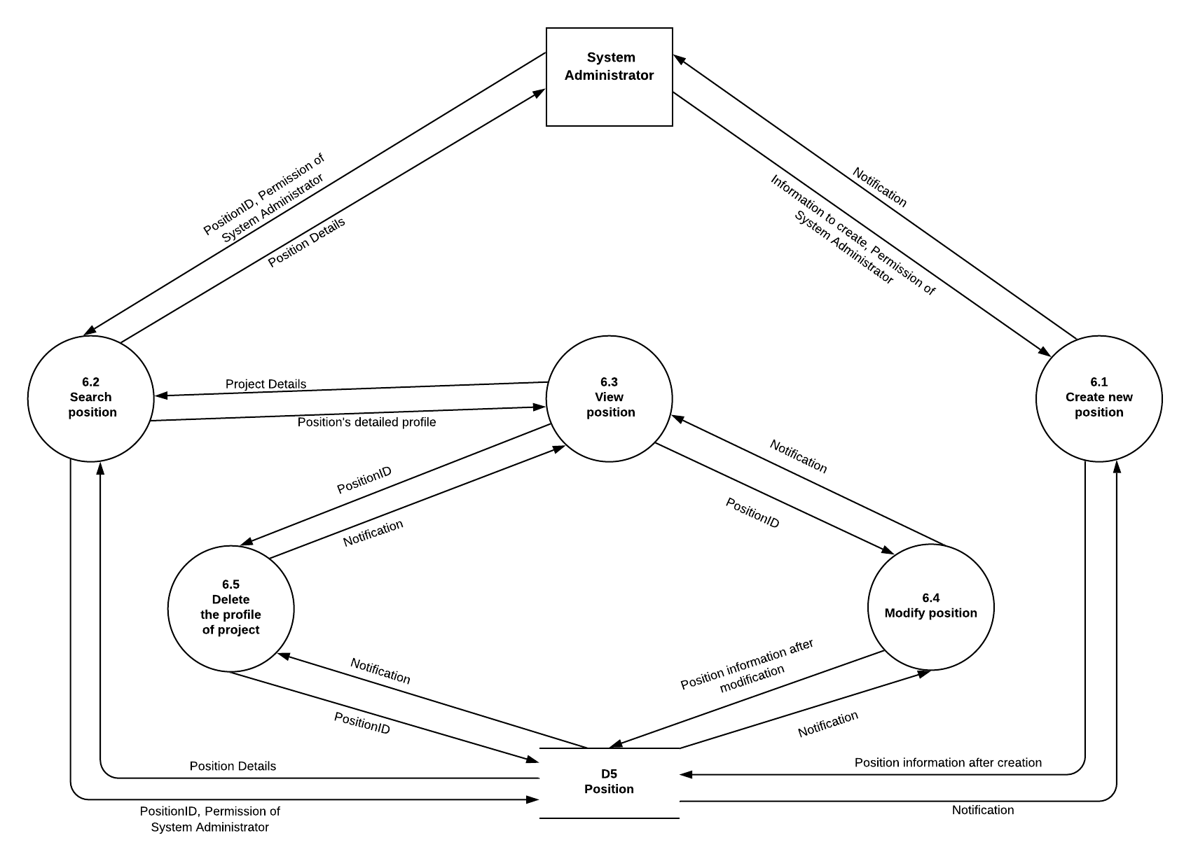

- Process Name
View profile and allowances.
- Process Description and Details.

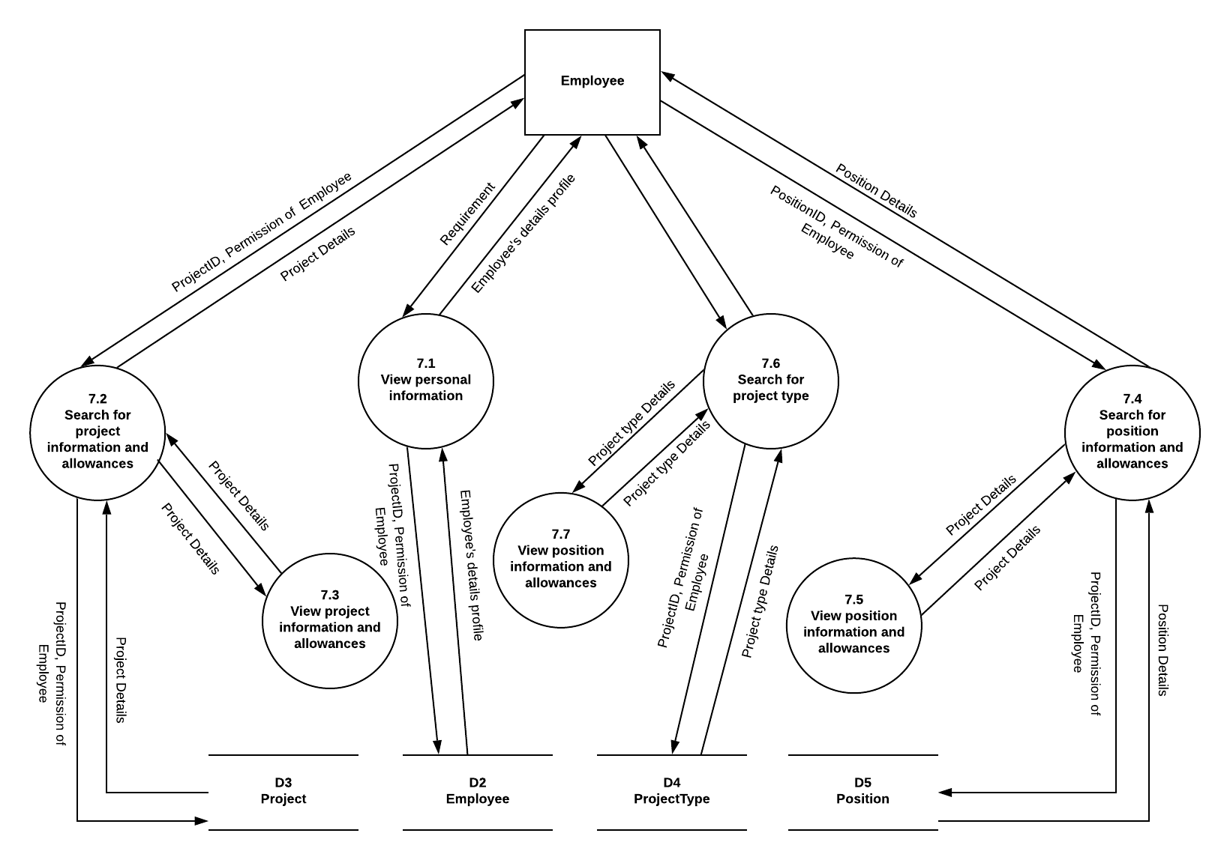

- Process Name
Approve and send notification letter.
- Process Description and Details.

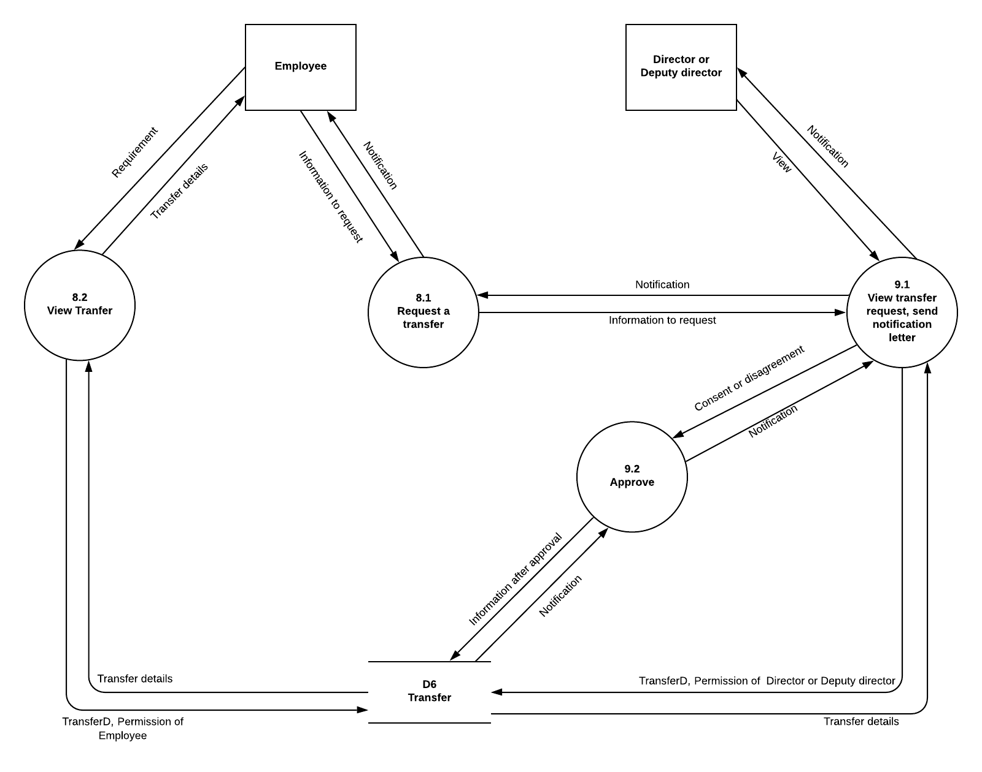
- Manage Admin:
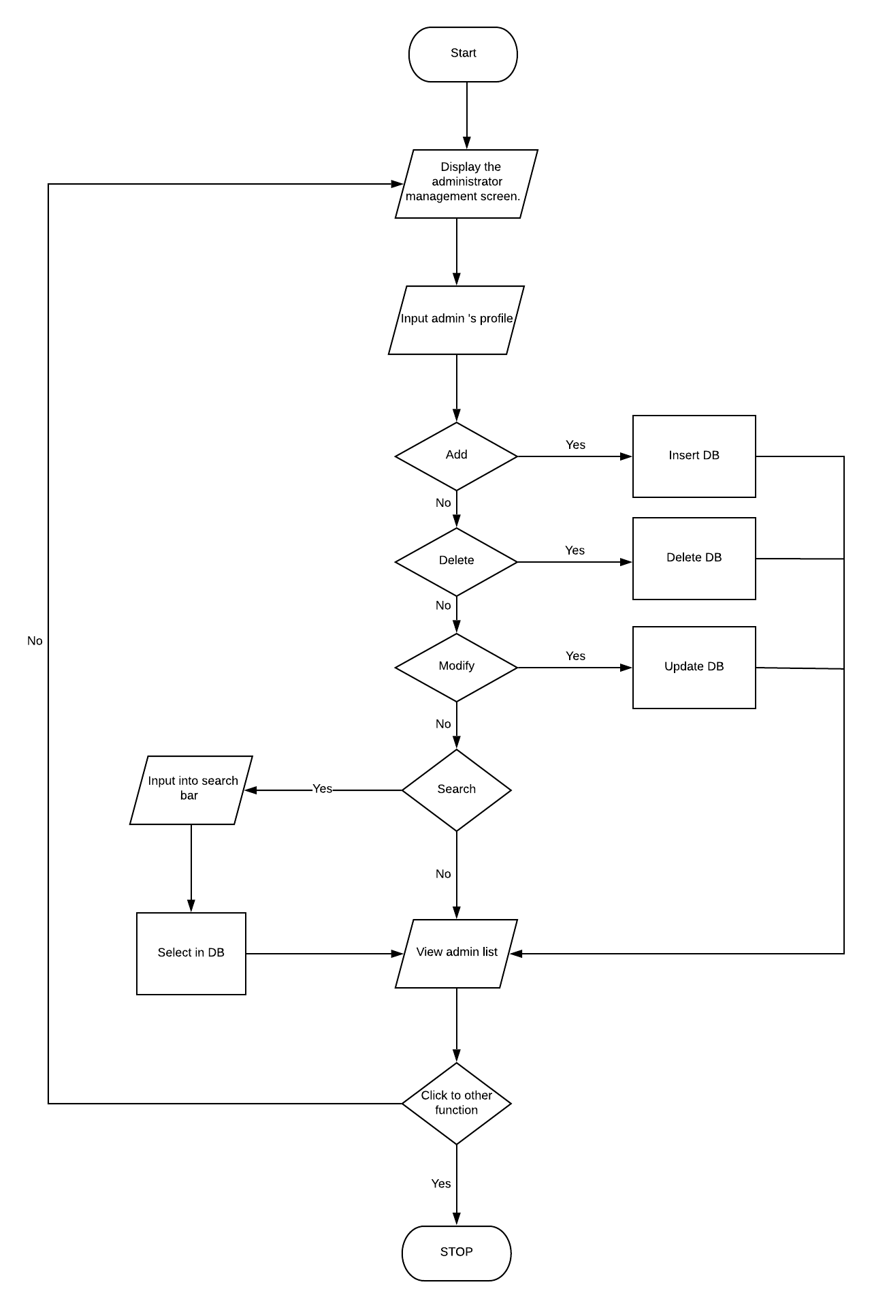

- Manage Employee
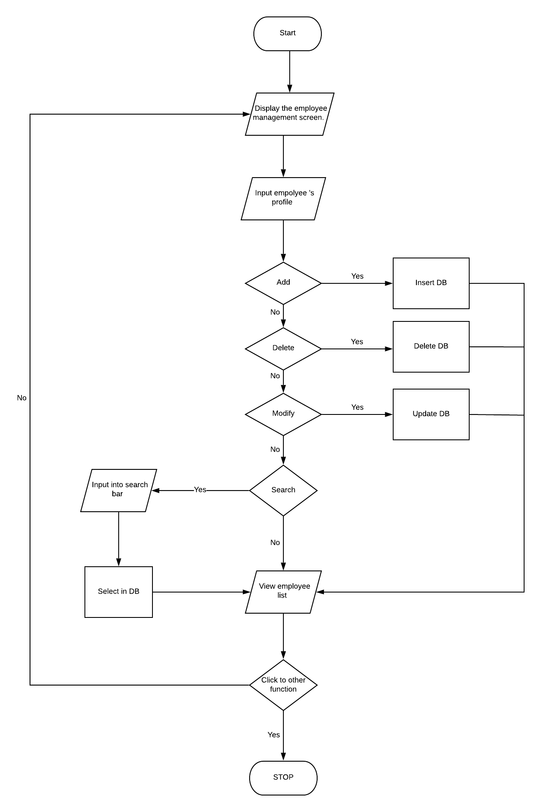

- Manage Project:

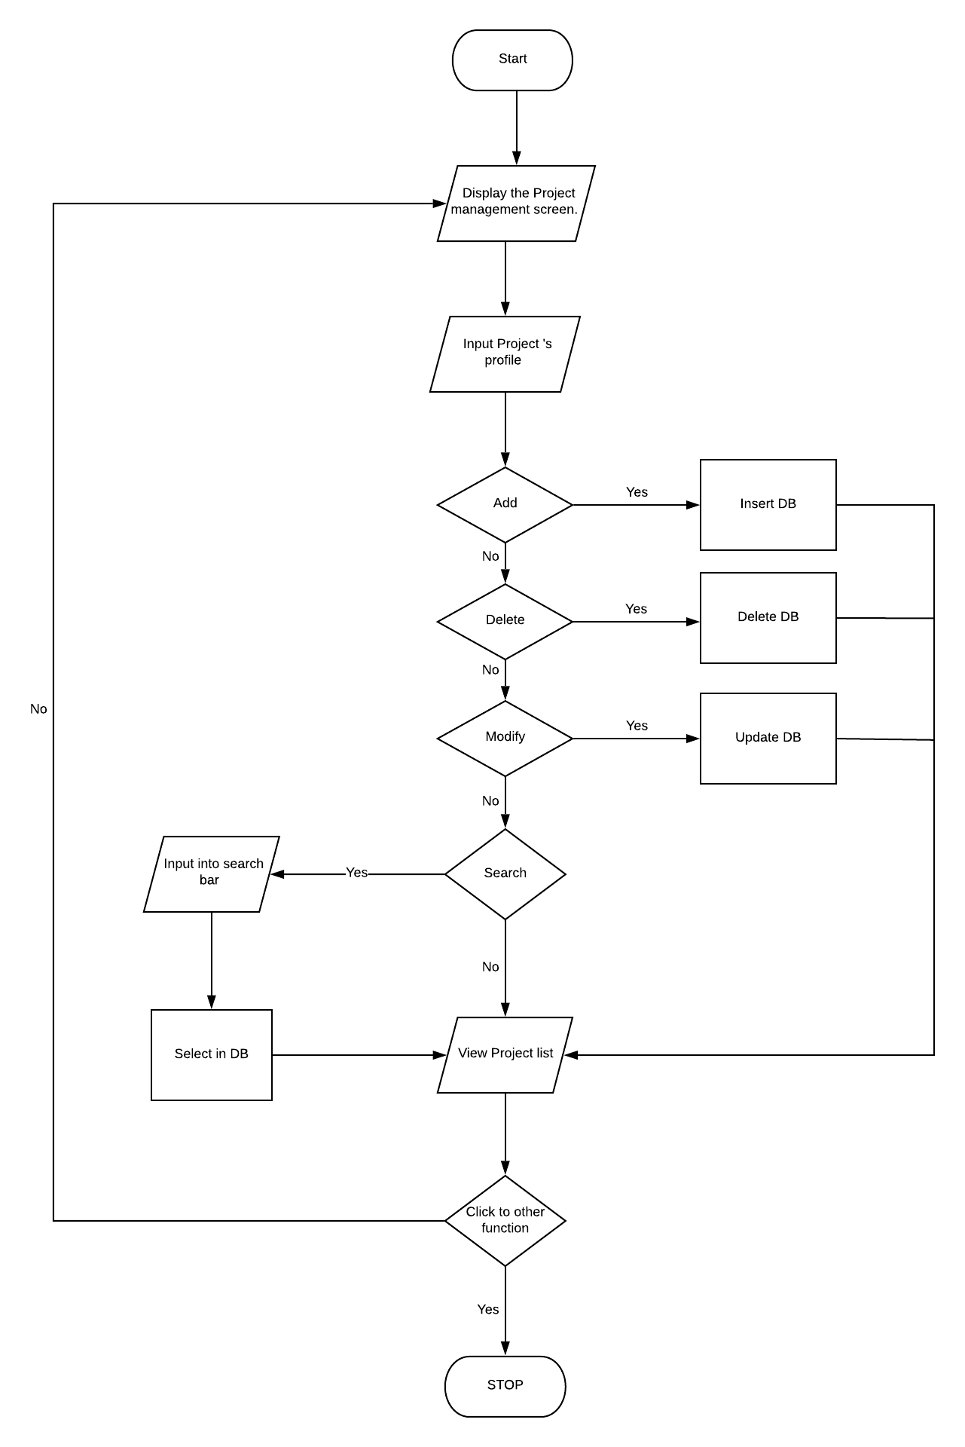

- Manage ProjectType:
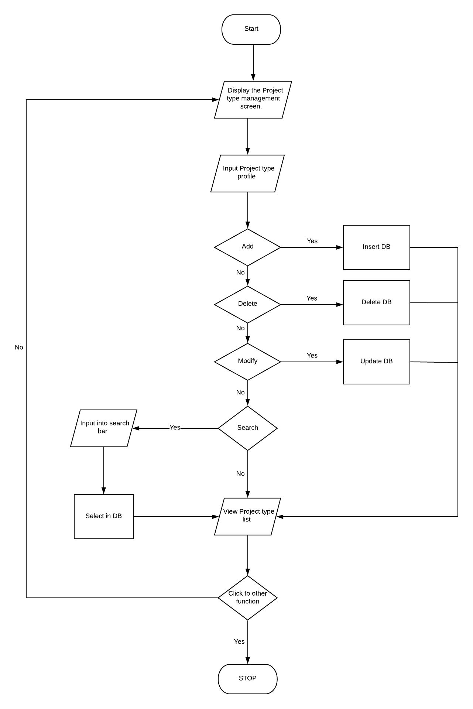

- Request a conversion
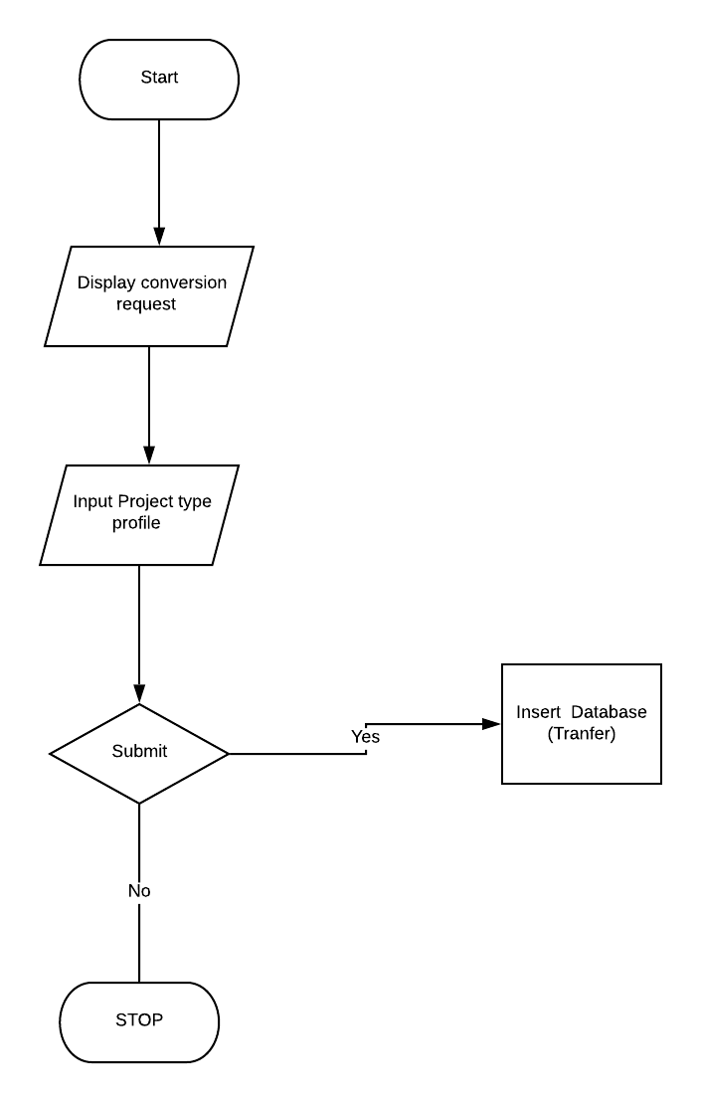

- Management approval
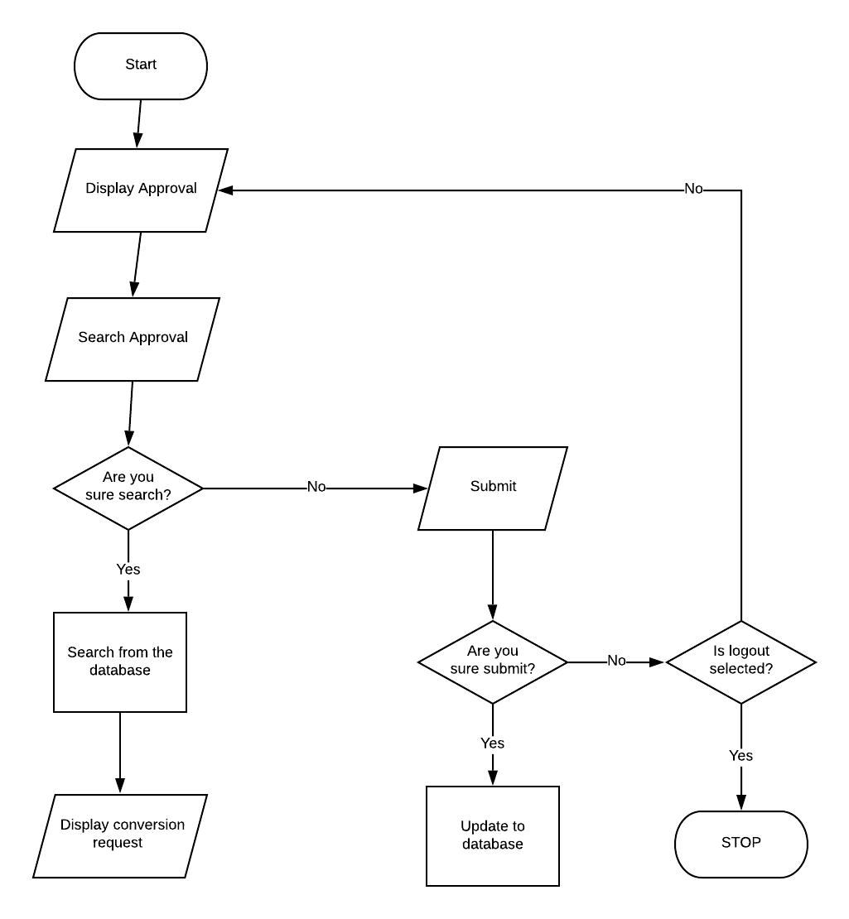
- File Names
This section lists commonly used file suffixes and name
  - File Suffixes
JavaSoft uses the following file suffixes:
File Type | Suffix
Java source  Java bytecode | .java  .class
  - Common File Names
Frequently used file names include:
File Name | Use
GNUmakefile  README | The preferred name for makefiles.  We use gnumake to build our software.  The preferred name for the file that summarizes the contents of a particular directory.
- File Organization
A file consists of sections that should be separated by blank lines and an optional comment identifying each section.
Files longer than 2000 lines are cumbersome and should be avoided.
  - Java Source Files
Each Java source file contains a single public class or interface. When private classes and interfaces are associated with a public class, you can put them in the same source file as the public class. The public class should be the first class or interface in the file.
Java source files have the following ordering:
• Beginning comments (see “Beginning Comments” on page 4)
• Package and Import statements; for example:
import java.applet.Applet;
import java.awt.*;
import java.net.*;
• Class and interface declarations
    - Beginning Comments
All source files should begin with a c-style comment that lists the programmer(s), the date, a copyright notice, and also a brief description of the purpose of the program. For example:
/*
* Classname
*
* Version info
*
* Copyright notice
*/
    - Package and Import Statements
The first non-comment line of most Java source files is a package statement. After that, import statements can follow. For example:
package java.awt;
import java.awt.peer.CanvasPeer;
    - Class and Interface Declarations
The following table describes the parts of a class or interface declaration, in the order that they should appear.
 | Part of Class/Interface  Declaration | Notes
1 | Class/interface documentation  comment (/**...*/) | See “Documentation Comments” on page 9 for  information on what should be in this comment
2 | class or interface statement
3 | Class/interface implementation  comment (/*...*/), if necessary | This comment should contain any class-wide or interface-wide information that wasn’t appropriate for the class/interface documentation comment
4 | Class (static) variables | First the public class variables, then the pro  tected, and then the private
5 | Instance variables | First public, then protected, and then pri  vate.
6 | Constructors
7 | Methods | These methods should be grouped by functional-ity rather than by scope or accessibility. Forexample, a private class method can be in between two public instance methods. The goal is to make reading and understanding the code eas-ier.
- Indentation
Four spaces should be used as the unit of indentation. The exact construction of the indentation (spaces vs. tabs) is unspecified. Tabs must be set exactly every 8 spaces (not 4).
  - Line Length
Avoid lines longer than 80 characters, since they’re not handled well by many terminals and tools.
Note: Examples for use in documentation should have a shorter line length—generally no more than 70 characters.
  - Wrapping Lines
When an expression will not fit on a single line, break it according to these general principles:
• Break after a comma.
• Break before an operator.
• Prefer higher-level breaks to lower-level breaks.
• Align the new line with the beginning of the expression at the same level on the previous line.
• If the above rules lead to confusing code or to code that’s squished up against the right margin, just indent 8 spaces instead. Here are some examples of breaking method calls:
function(longExpression1, longExpression2, longExpression3,
longExpression4, longExpression5);
var = function1(longExpression1,
function2(longExpression2,
longExpression3));
- Comments
Java programs can have two kinds of comments: implementation comments and documentation comments. Implementation comments are those found in C++, which are delimited by /*...*/, and //. Documentation comments (known as “doc comments”) are Java-only, and are delimited by /**...*/. Doc comments can be extracted to HTML files using the javadoc tool.
Implementation comments are mean for commenting out code or for comments about the particular implementation. Doc comments are meant to describe the specification of the code, from an implementation-free perspective. to be read by developers who might not necessarily have the source code at hand.
Comments should be used to give overviews of code and provide additional information that is not readily available in the code itself. Comments should contain only information that is relevant to reading and understanding the program. For example, information about how the corresponding package is built or in what directory it resides should not be included as a comment.
Discussion of nontrivial or nonobvious design decisions is appropriate, but avoid duplicating information that is present in (and clear from) the code. It is too easy for redundant comments to get out of date. In general, avoid any comments that are likely to get out of date as the code evolves.
Note: The frequency of comments sometimes reflects poor quality of code. When you feel compelled to add a comment, consider rewriting the code to make it clearer.
Comments should not be enclosed in large boxes drawn with asterisks or other characters.
Comments should never include special characters such as form-feed and backspace.
  - Implementation Comment Formats
Programs can have four styles of implementation comments: block, single-line, trailing and end-of-line.
    - Block Comments
Block comments are used to provide descriptions of files, methods, data structures and algorithms. Block comments should be used at the beginning of each file and before each method. They can also be used in other places, such as within methods. Block comments inside a function or method should be indented to the same level as the code they describe. A block comment should be preceded by a blank line to set it apart from the rest of the code. Block comments have an asterisk “*” at the beginning of each line except the first.
/*
* Here is a block comment.
*/
Block comments can start with /*-, which is recognized by indent(1) as the beginning of a block comment that should not reformatted. Example:
/*
* Here is a block comment with some very special
* formatting that I want indent(1) to ignore.
*
* one
* two
* three
*/
Note: If you don’t use indent(1), you don’t have to use /*- in your code or make any other concessions to the possibility that someone else might run indent(1) on your code.
    - Single-Line Comments
Short comments can appear on a single line indented to the level of the code that follows. If a comment can’t be written in a single line, it should follow the block comment format (see section 4.1.1). A single-line comment should be preceded by a blank line. Here’s an example of a single-line comment in Java code :
if (condition) {
/* Handle the condition. */
...
}
    - Trailing Comments
Very short comments can appear on the same line as the code they describe, but should be shifted far enough to separate them from the statements. If more than one short comment appears in a chunk of code, they should all be indented to the same tab setting. Avoid the assembly language style of commenting every line of executable code with a trailing comment.
Here’s an example of a trailing comment in Java code (also see “Documentation Comments”
on page 9):
if (a == 2) {
return TRUE; /* special case */
} else {
return isprime(a); /* works only for odd a */
}
    - End-Of-Line Comments
The // comment delimiter begins a comment that continues to the newline. It can comment out a complete line or only a partial line. It shouldn’t be used on consecutive multiple lines for text comments; however, it can be used in consecutive multiple lines for commenting out sections of code. Examples of all three styles follow:
if (foo > 1) {
// Do a double-flip.
...
}
else
return false; // Explain why here.
//if (bar > 1) {
//
// // Do a triple-flip.
// ...
//}
//else
// return false;
  - Documentation Comments
Note: See “Java Source File Example” on page 19 for examples of the comment formats described here.
For further details, see “How to Write Doc Comments for Javadoc” which includes information on the doc comment tags (@return, @param, @see):
http://java.sun.com/products/jdk/javadoc/writingdoccomments.html
For further details about doc comments and javadoc, see the javadoc home page at:
http://java.sun.com/products/jdk/javadoc/
Doc comments describe Java classes, interfaces, constructors, methods, and fields. Each doc comment is set inside the comment delimiters /**...*/, with one comment per API. This comment should appear just before the declaration:
/**
* The Example class provides ...
*/
class Example { ...
Notice that classes and interfaces are not indented, while their members are. The first line of doc comment (/**) for classes and interfaces is not indented; subsequent doc comment lines each have 1 space of indentation (to vertically align the asterisks). Members, including constructors, have 4 spaces for the first doc comment line and 5 spaces thereafter.
If you need to give information about a class, interface, variable, or method that isn’t appropriate for documentation, use an implementation block comment (see section 4.1.1) or single-line (see section 4.1.2) comment immediately after the declaration. For example, details about the implementation of a class should go in in such an implementation block comment following the class statement, not in the class doc comment.
Doc comments should not be positioned inside a method or constructor definition block, because Java associates documentation comments with the first declaration after the comment.

- Declarations
  - Number Per Line
One declaration per line is recommended since it encourages commenting. In other words,
int level; // indentation level
int size; // size of table
is preferred over
int level, size;
In absolutely no case should variables and functions be declared on the same line. Example:
long dbaddr, getDbaddr(); // WRONG!
Do not put different types on the same line. Example:
int foo, fooarray[]; //WRONG!
Note: The examples above use one space between the type and the identifier. Another acceptable alternative is to use tabs, e.g.:

int  int  Object | level; // indentation level  size; // size of table  currentEntry; // currently selected table entry
  - Placement
Put declarations only at the beginning of blocks. (A block is any code surrounded by curly braces “{” and “}”.) Don’t wait to declare variables until their first use; it can confuse the unwary programmer and hamper code portability within the scope.
void MyMethod() {
int int1; // beginning of method block
if (condition) {
int int2; // beginning of "if" block
...
}
}
The one exception to the rule is indexes of for loops, which in Java can be declared in the for statement:
for (int i = 0; i < maxLoops; i++) { ...
Avoid local declarations that hide declarations at higher levels. For example, do not declare the same variable name in an inner block:

int count;
...
func() {
if (condition) {
int count; // AVOID!
...
}
...
}
  - Initialization
Try to initialize local variables where they’re declared. The only reason not to initialize a variable where it’s declared is if the initial value depends on some computation occurring first.
  - Class and Interface Declarations
When coding Java classes and interfaces, the following formatting rules
should be followed:
• No space between a method name and the parenthesis “(“ starting its parameter list
• Open brace “{” appears at the end of the same line as the declaration statement
• Closing brace “}” starts a line by itself indented to match its corresponding opening statement, except when it is a null statement the “}” should appear immediately after the
“{“
class Sample extends Object {
int ivar1;
int ivar2;
Sample(int i, int j) {
ivar1 = i;
ivar2 = j;
}
int emptyMethod() {}
...
}
• Methods are separated by a blank line
- Statements
  - Simple Statements
Each line should contain at most one statement. Example:
argv++; argc--; // AVOID!

Do not use the comma operator to group multiple statements unless it is for an obvious reason.
Example:
if (err) {
Format.print(System.out, “error”), exit(1); //VERY WRONG!
}
  - Compound Statements
Compound statements are statements that contain lists of statements enclosed in braces “{ statements }”. See the following sections for examples.
• The enclosed statements should be indented one more level than the compound statement.
• The opening brace should be at the end of the line that begins the compound statement; the closing brace should begin a line and be indented to the beginning of the compound statement.
• Braces are used around all statements, even singletons, when they are part
of a control structure, such as a if-else or for statement. This makes it easier to add statements without accidentally introducing bugs due to forgetting to add braces.
  - return Statements
A return statement with a value should not use parentheses unless they make the return value more obvious in some way. Example:
return;
return myDisk.size();
return (size ? size : defaultSize);
  - if, if-else, if-else-if-else Statements
The if-else class of statements should have the following form:
if (condition) {
statements;
}
if (condition) {
statements;
} else {
statements;
}
if (condition) {
statements;
} else if (condition) {
statements;
} else if (condition) {
statements;
}

Note: if statements always use braces {}. Avoid the following error-prone form:
if (condition) //AVOID! THIS OMITS THE BRACES {}!
statement;
  - for Statements
A for statement should have the following form:
for (initialization; condition; update) {
statements;
}
An empty for statement (one in which all the work is done in the initialization, condition, and update clauses) should have the following form:
for (initialization; condition; update);
When using the comma operator in the initialization or update clause of a for statement, avoid the complexity of using more than three variables. If needed,
use separate statements before the for loop (for the initialization clause) or at the end of the loop (for the update clause).
  - while Statements
A while statement should have the following form:
while (condition) {
statements;
}
An empty while statement should have the following form:
while (condition);
  - do-while Statements
A do-while statement should have the following form:
do {
statements;
} while (condition);
  - switch Statements
A switch statement should have the following form:
switch (condition) {
case ABC:
statements;
/* falls through */
case DEF:
statements;
break;
case XYZ:
statements;
break;
default:
statements;
break;
}
Every time a case falls through (doesn’t include a break statement), add a comment where the
break statement would normally be. This is shown in the preceding code example with the
/* falls through */ comment.
Every switch statement should include a default case. The break in the default case is
redundant, but it prevents a fall-through error if later another case is added.
  - try-catch Statements
A try-catch statement should have the following format:
try {
statements;
} catch (ExceptionClass e) {
statements;
}

Project Ref.  No.: | Project Title: | Activity Plan Prepared By: |  | Date of Preparation of Activity Plan:
Task Sub  division: | Description | Planned Start Date | Actual Start Date | Actual Days | Team Members Names | Status
1. | From 3  Form 5  Form 6  Form 7  1.Manage Admin  2.Manage Employee  3.Manage Transfer  4.Manage Approval | 10/9/2019 | 23/9/2019 | 13 day | Tran Ngoc Nguyen | completed99%
2. | Form 2  Form 4  Form 7  - Manage Position  - Manage Report | 10/9/2019 | 23/9/2019 | 13 day | Hua Huy Hoang | completed99%
3. | Form 1  Form 4  Form 5  Form 7  - Login and logout  - View profile  - Manage Project. | 10/9/2019 | 23/9/2019 | 13 day | Phan Quang Lam | completed99%
4. | Form 2a  Form 5  Form7  1.ManageProjectType. | 10/9/2019 | 23/9/2019 | 13 day | Nguyen Thanh Hung | completed99%

